The Alaska Naval Militia: Protecting Our State
Alaska is the only Arctic state in the union. Alaska has 34,000 miles of coastline, more than the rest of the United States combined, and over 800,000 miles of navigable rivers. Alaska’s unique strategic location highlights the need for State and Federal mission assurance and a robust Alaska Organized Militia (AKOM). The ANM represent one of the four pillars under the AKOM which includes the Air Guard, Army Guard, Alaska State Defense Force, and the Alaska Naval Militia.

The ANM is a group of citizen Sailors and Marines who have pledged service to both Federal and State government. Members of the ANM maintain Federal Reserve Component readiness through the Alaska Navy Reserve Center (NRC) and the Marine Corp Reserve Training Facility both located on Joint Base Elmendorf Richardson (JBER). ANM members are active drilling members of the US Navy and the US Marine Corp Reserve. AKNM members are additionally aligned with the Alaska National Guard for direct support of the State of Alaska as requested. ANM service members are eligible to mobilize in support of our nation on federal orders or the State of Alaska on state orders. Up to 5% of the ANM may be retired Military members for the purpose of leadership continuity. The ANM is one of five Naval Militia’s recognized under Title 10 USC. Joining the ANM is voluntary and an optional benefit for Selected Reservists living in Alaska.

ANM members live in Alaska and represent Reserve commands all over the globe. They are typically administratively supported by the Alaska Naval Reserve Center (NRC) or the Marine Corp Reserve Training Facility. Support units located in Alaska include the Volunteer Training Unit (VTU), the Reserve Support Unit (RSU), 4th Law Enforcement Battalion (4th LEB) Delta Company, Alaska Command (ALCOM), and the Navy Medicine Readiness and Training Command Camp Pendleton (NMRT-CP). ANM members provide operational support to the US Navy and Marine Corps through Annual Training (AT, providing support to their gaining command) and Individual Duty Training Travel (IDTT, providing operational support to the Fleet).

In addition to providing a valuable resource for Alaska, the ANM offers its members a unique opportunity to serve their community and their country. Members train in a variety of areas, including navigation, seamanship, military medicine, construction skills, cargo handling, explosive outload teams, intelligence, military police, joint operations, and small boat operations. ANM members undergo rigorous physical training and medical screening to ensure they are ready for any situation.

NRC Anchorage also supports Navy Funeral Honors and ANM members honor our shipmates at Veteran funerals through out the state of Alaska. In FY22 ANM members supported 60 Veteran funerals. ANM members provide uniformed detail to present the core elements of a Navy funeral honors ceremony and often travel to remote Alaska on short notice.

One of the biggest advantages of the ANM is that its members are drawn from the local community. They know the coastline, the waterways, and the people who live and work in the area. This allows them to respond quickly and effectively to any situation that may arise. The ANM stands ready to responded when called upon to assist the people of Alaska.
The ANM is an important part of Alaska’s defense and emergency response capabilities. ANM members are dedicated to serving their community and their country; they are ready to respond to any situation. As Alaskans, we can all take pride in the service and sacrifice of these citizen Sailors and Marines. The ANM reaffirms the Alaskan tradition of volunteer service to Community, State, and Nation.

ANM members on the ground in support the Typhoon Merbok response.

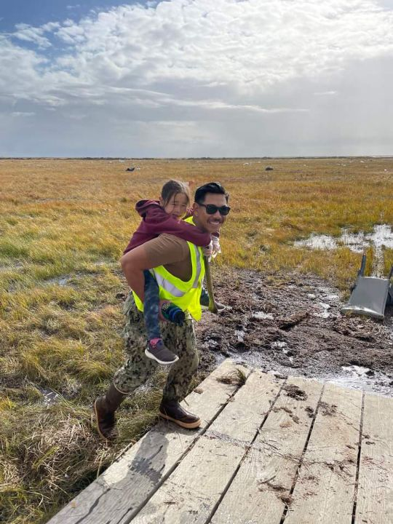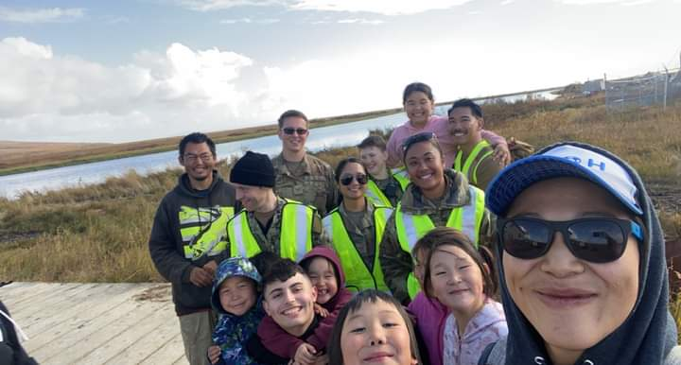

ANM members take a break for physical training to swear in with LCDR Dave Allen (retired).

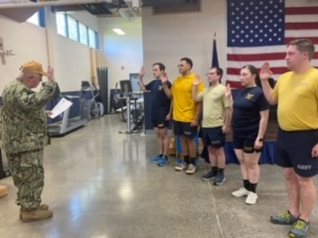

ANM members enjoying some H60 time in support of Typhoon Merbok response.

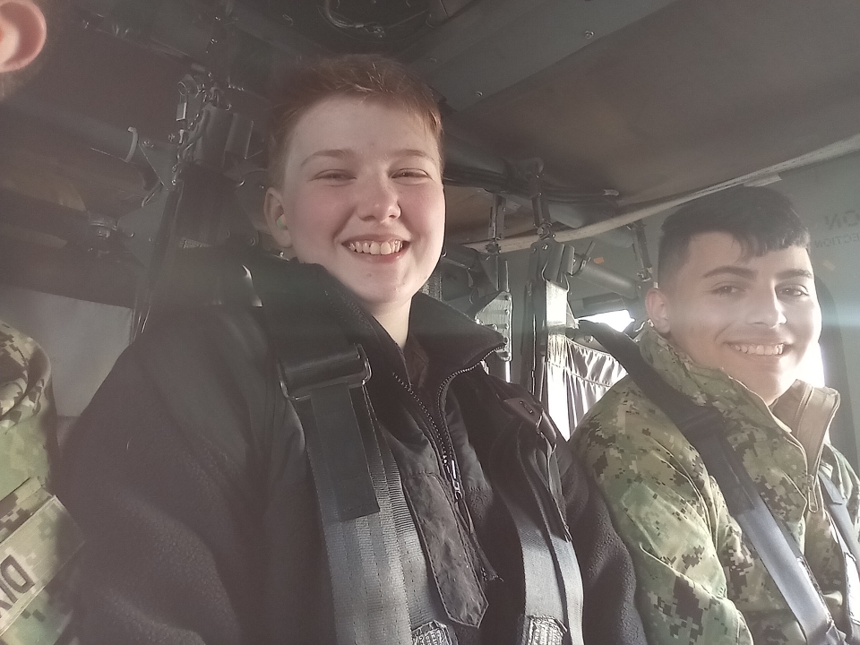

ANM members travel to support Typhoon Merbok response on an Alaska Air Guard C130.

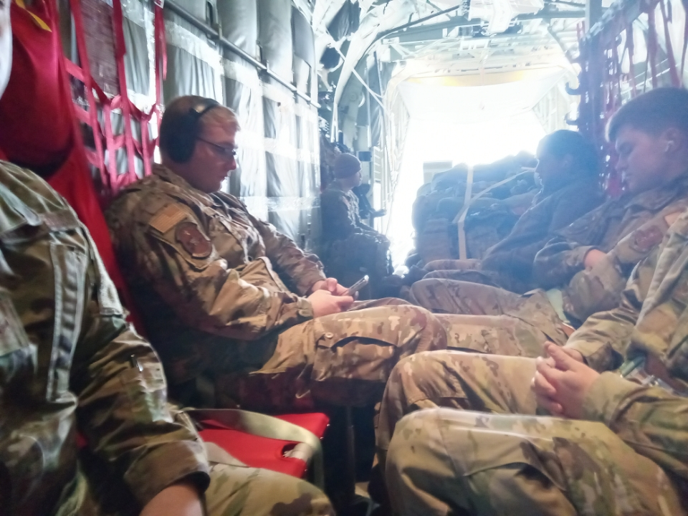
EO3 Moss presents flag at Ft Richardson National Cemetery.

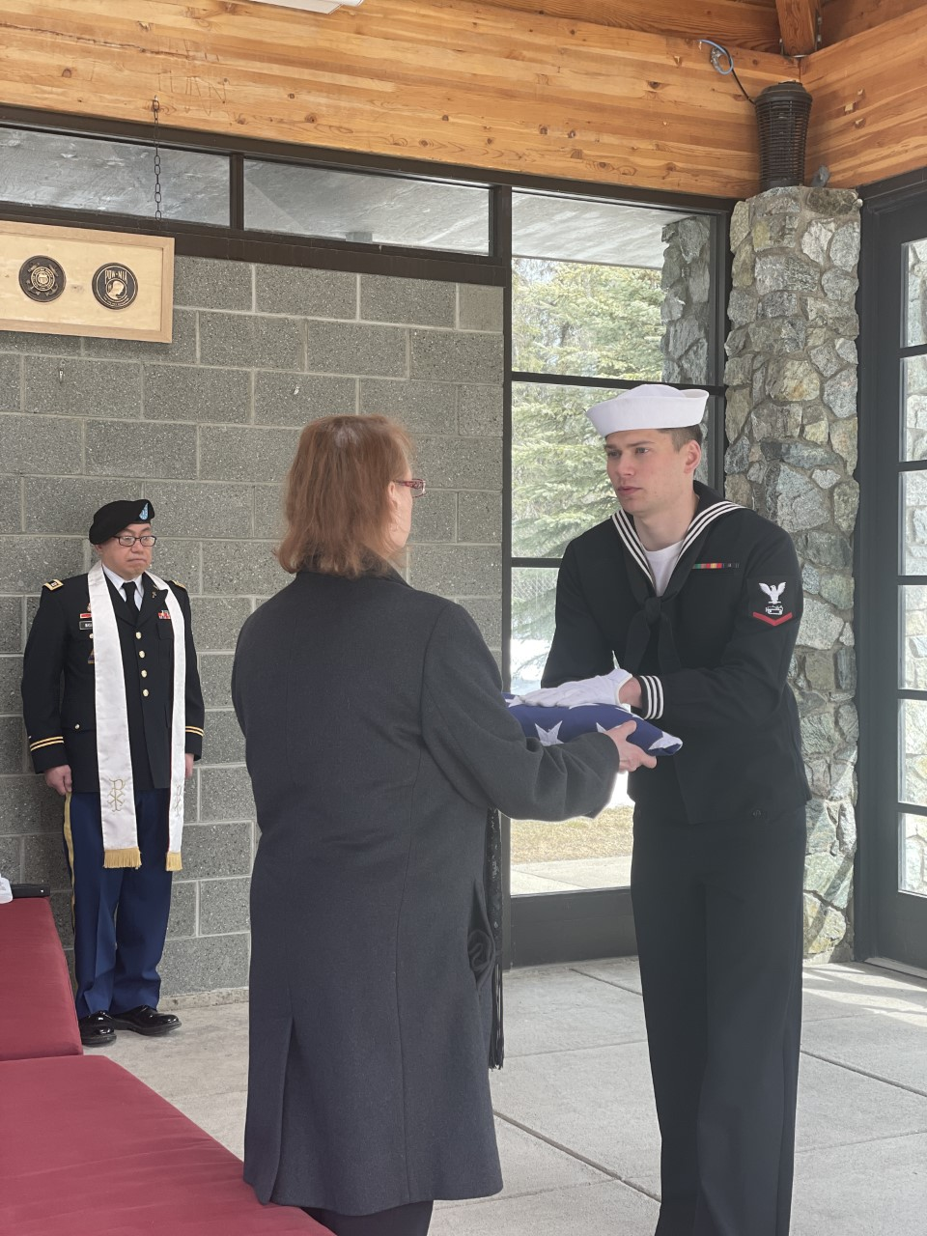

EMN1 Ciampini, HM3 Kyle, HM3 Nguyen, BU3 Farley, HT1 Beacham form up before a funeral detail
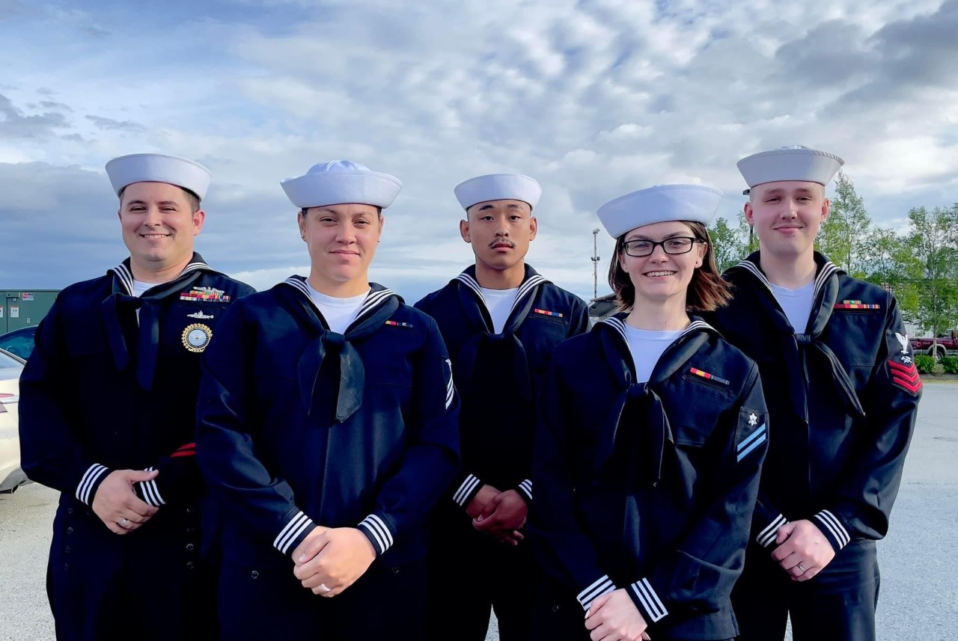.

HM1 Cortes (left) and HM1 Salvador travel to Sitka for a funeral detail
